**NBAD FINAL PROJECT**

**TESTING**

**KARTHEEK SANISETTY**

**801348859**

1. Atleast 1 Unit test
2. E2E test
3. 1 visual Regression test

* This is the signup page of the website

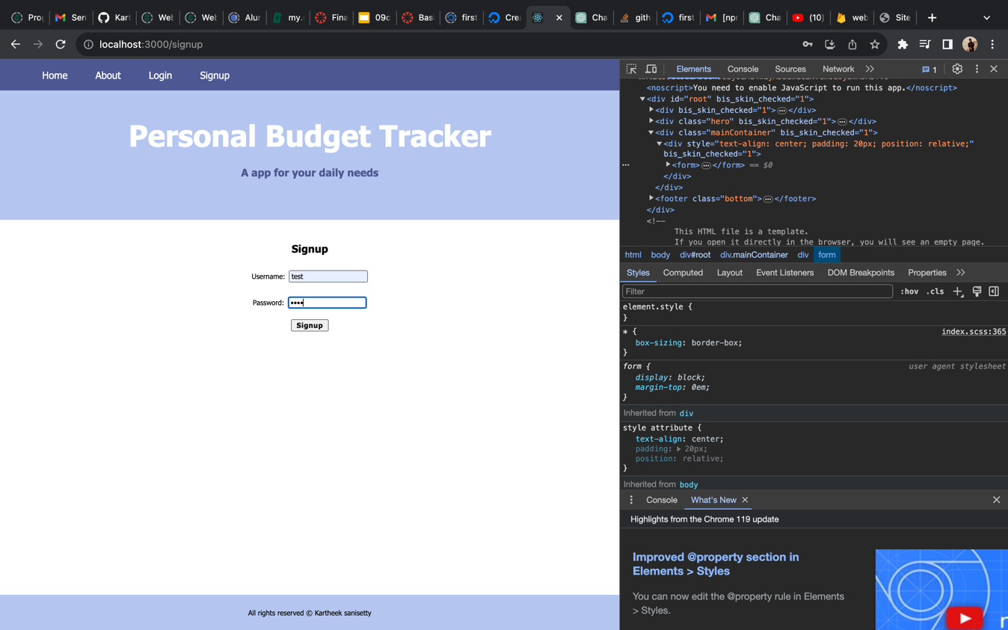

* When we have entered the data in the signup page we can see those details in the db.

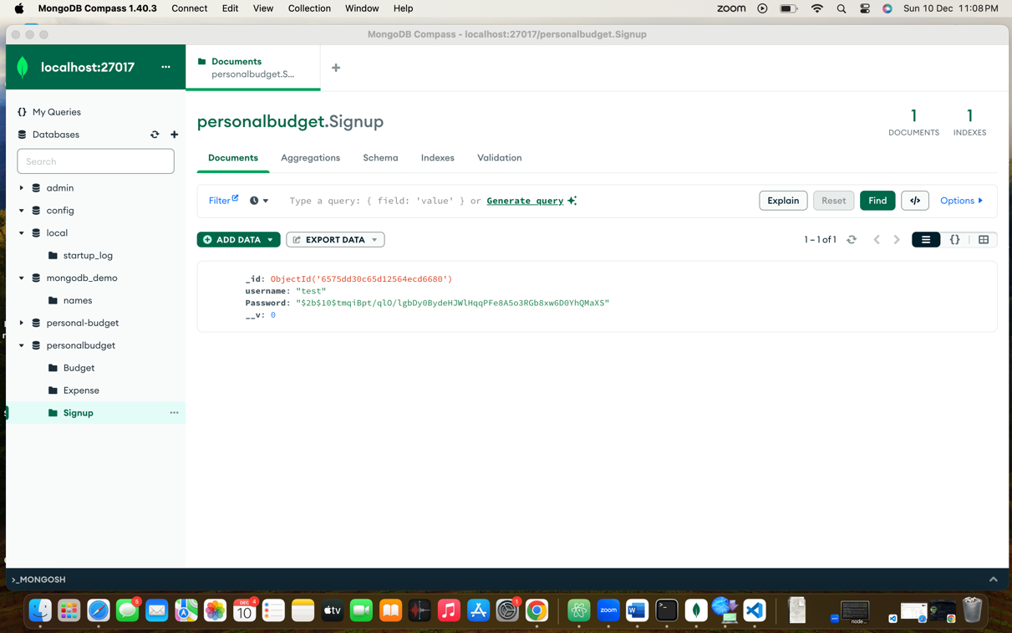

* This will be our login page where we will be logging in into our website.

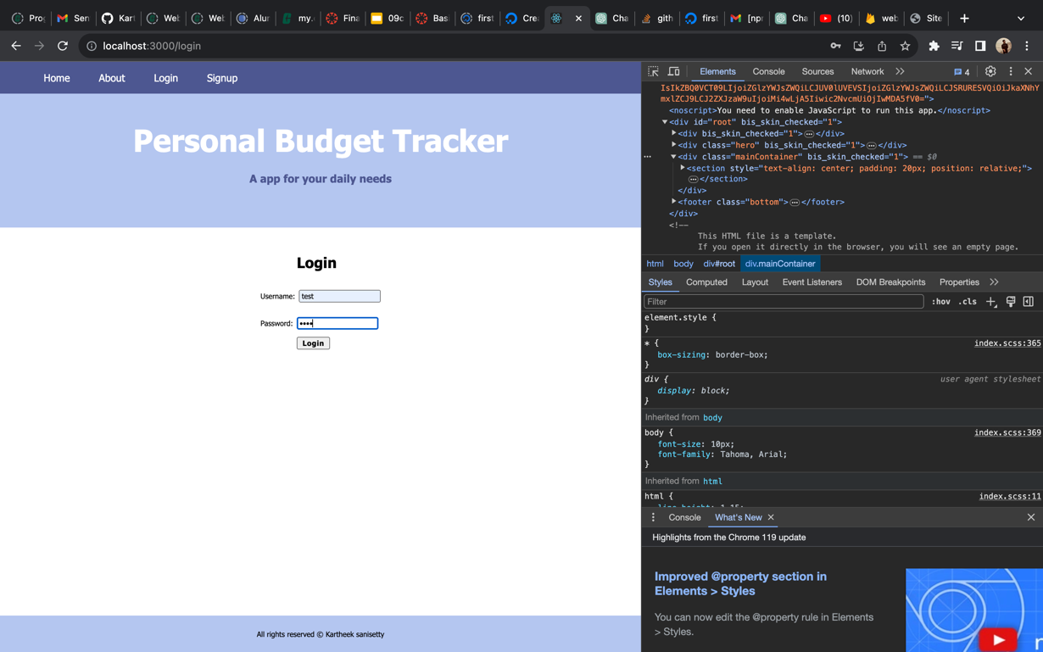

* This will be our dashboard where we will be entering the expenses.

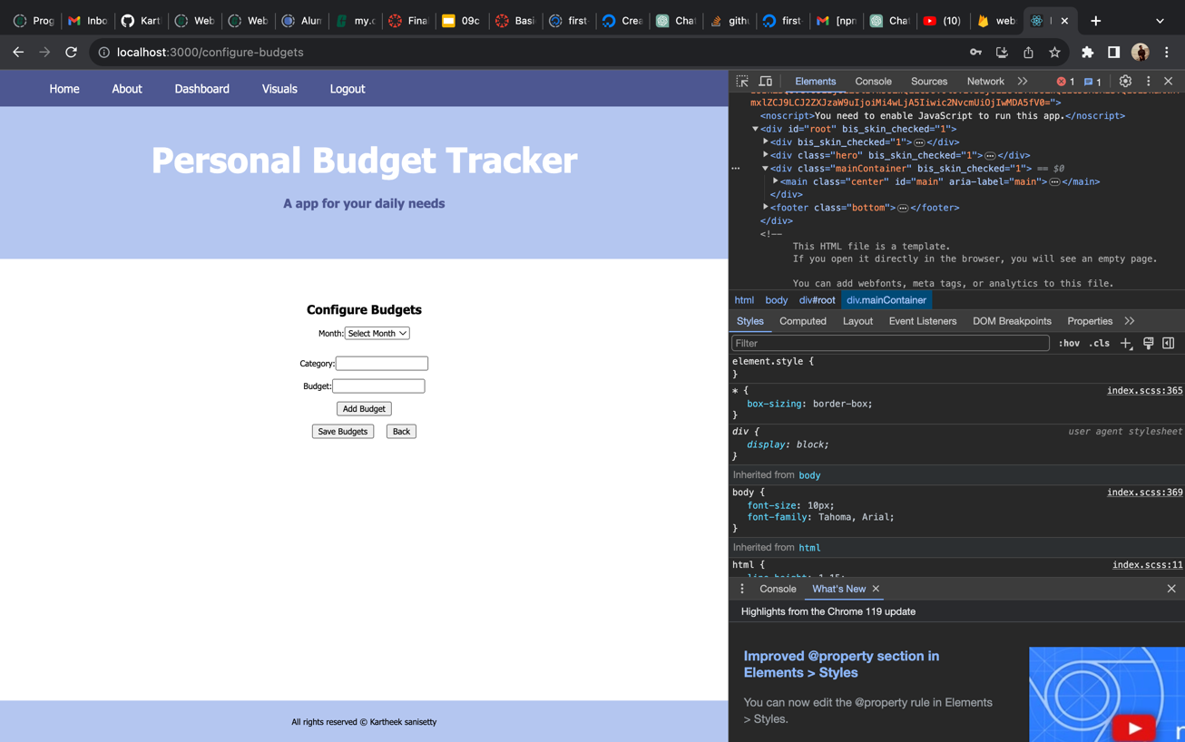

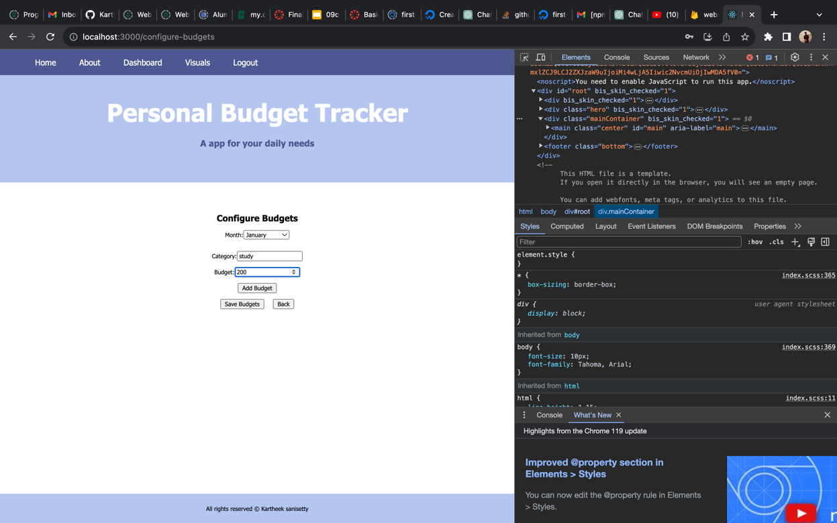

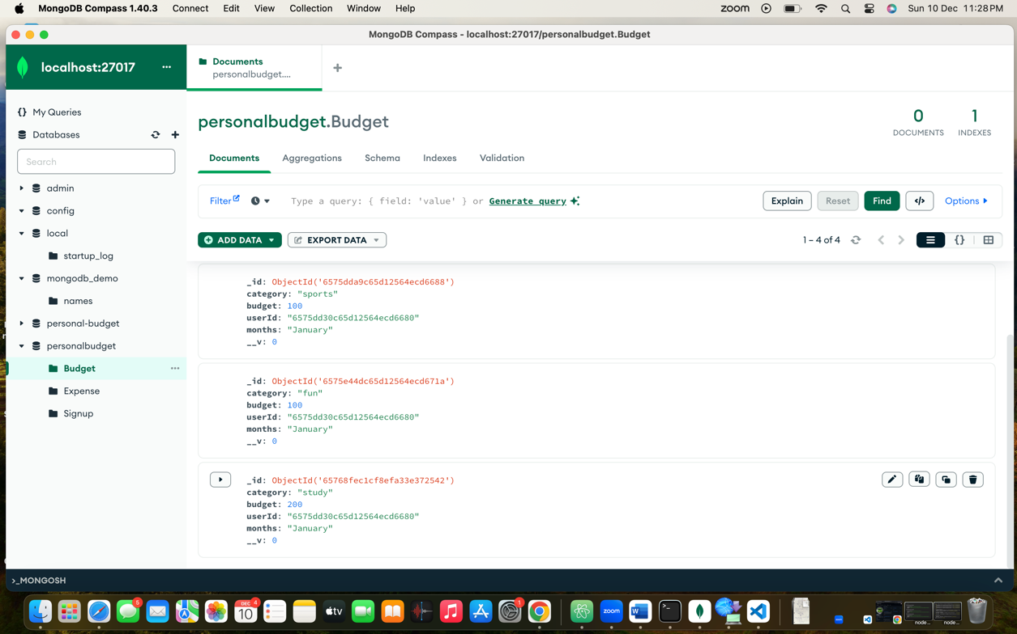

* The page will be expire within 60 seconds.

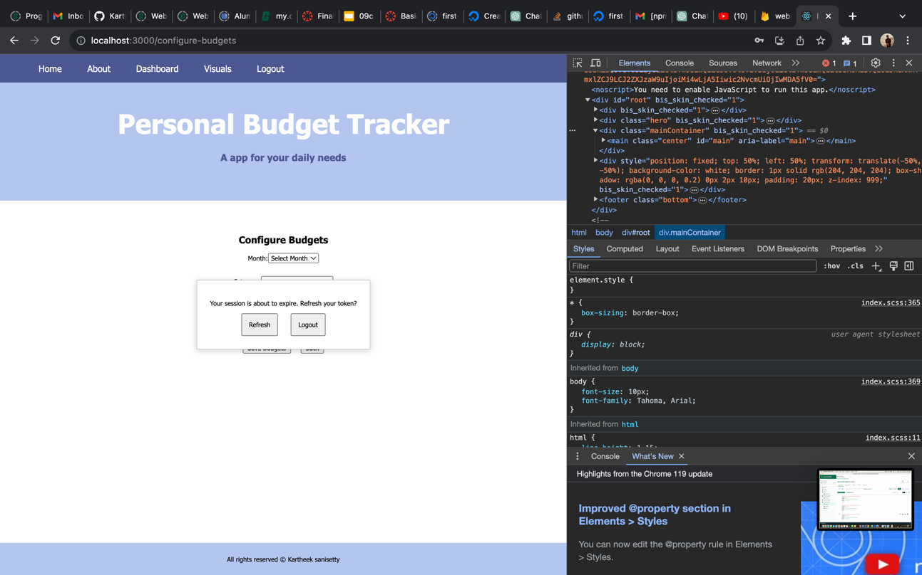

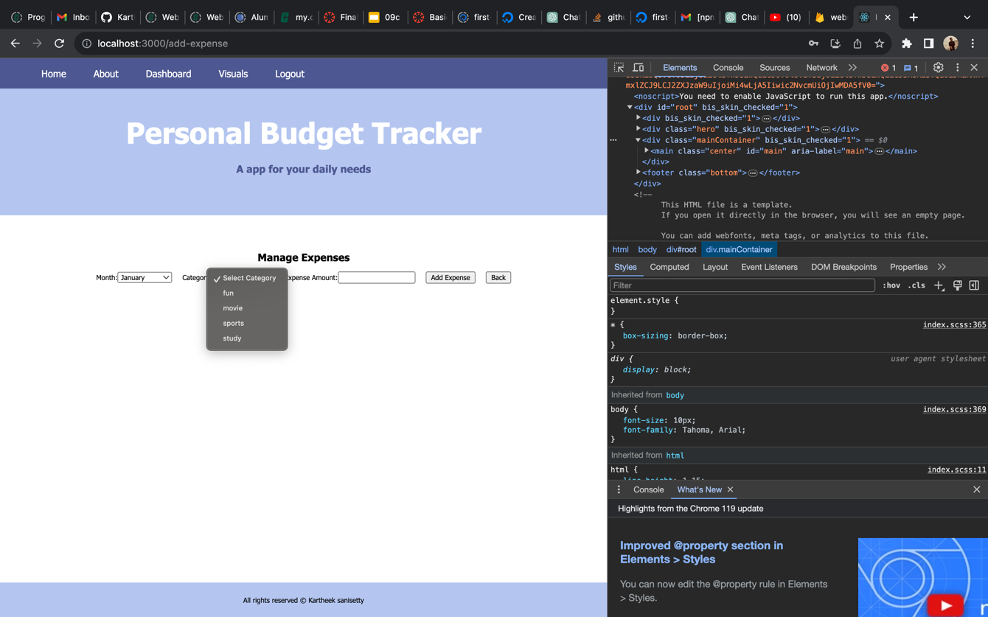

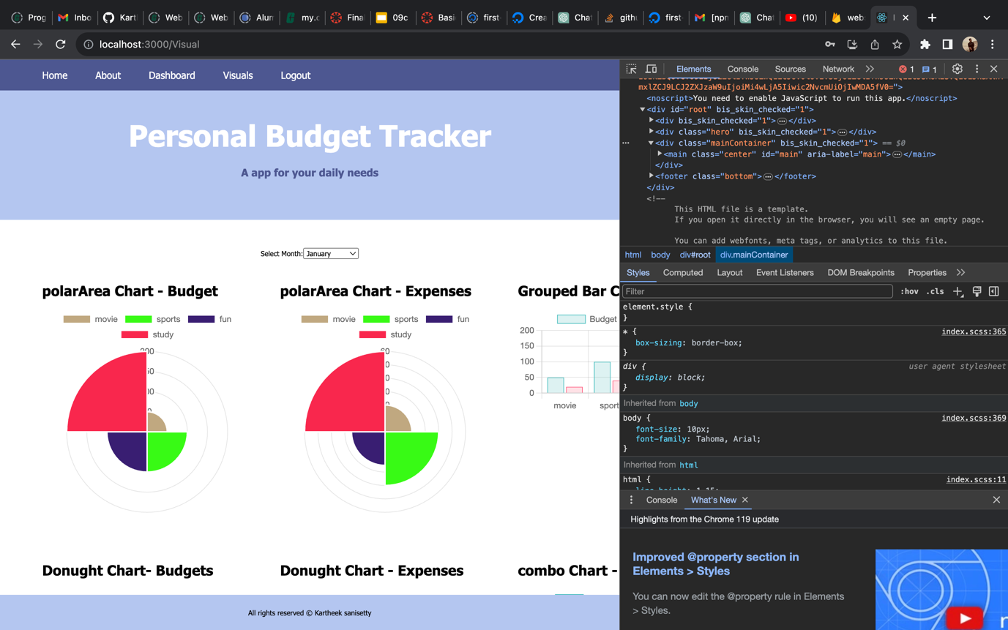

The website is running successfully without any errors and here we can see the E2E testing screenshots. The Website is running in the **localhost:3000.**

**Homepage test:**

// homepage.e2e-spec.ts

import { browser, by, element } from 'protractor';

describe('Homepage', () => {

it('should display welcome message', async () => {

await browser.get('/');

const welcomeMessage = element(by.css('app-homepage h1')).getText();

expect(welcomeMessage).toEqual('Welcome to Your App');

});

});

**Login/logout test:**

// login-logout.e2e-spec.ts

import { browser, by, element } from 'protractor';

describe('Login and Logout', () => {

it('should login and logout successfully', async () => {

// Implement login steps

// Navigate to login page

await browser.get('/login');

// Perform login actions (enter credentials, click login button)

// Check if user is redirected to the dashboard after login

expect(await browser.getCurrentUrl()).toContain('/dashboard');

// Perform logout actions

const logoutButton = element(by.id('logout-button'));

await logoutButton.click();

// Check if user is redirected to the homepage after logout

expect(await browser.getCurrentUrl()).toContain('/');

});

});

**Signup Test:**

// signup.e2e-spec.ts

import { browser, by, element } from 'protractor';

describe('Signup', () => {

it('should sign up a new user', async () => {

// Implement signup steps

// Navigate to signup page

await browser.get('/signup');

// Perform signup actions (enter signup details, click signup button)

// Check if user is redirected to the dashboard after signup

expect(await browser.getCurrentUrl()).toContain('/dashboard');

});

});